CSCI 3350 Mid-Term Exam

Take-Home, Open-Book Exam

**Instructions / Important:**

* Please submit the finished exam paper in word (.docx) OR pdf (.pdf) file format to D2L digital dropbox.
* This is a take-home, open-book exam. Students are required to do their own research and submit their own work.
* Students should NOT discuss this exam with another person.
* If two students submit similar answers or similar required examples, both students will receive 0 for this exam.
  + Both students will be referred to the Office of Student Affairs for a hearing.
* If questions below require students to “**explain**”, please explain in your own words, or points will be deducted.
* Please insert real-world examples, or websites, or images, or screen captures to support your answer. Please **do NOT copy** examples from course slides / course textbooks / **your past assignments** (0 points if copy from slides / textbook / assignments).
* Please feel free to insert new pages to this document.

I understand and accept the APSU Code of Student Conduct:

PRINT NAME: Paul Buske

**Q1** (9 points):

[If two students submit similar answers or similar required examples, both students will receive 0 for this exam.]

List and describe at least three Web hosting considerations. (3 points)

(Stated in D2L > PowerPoint Slide > Non Designer Web Book - other topics).

Note: The only reference related to this topic is on the slideshow. I checked the Non Designer Web Book and it does not go into detail regarding these considerations.

1. Price. This consideration is related to the cost of hosting the website. A designer must consider the cost of storage space, how to monetize traffic to the site, and any contracts related to hosting the site. Storage space comes at a premium and if your website hosts large files such as photos then alternative solutions such as standing up one’s own server may be more cost effective. If enough traffic comes through the website, then the designer may be able to monetize the web traffic using advertisement deals. Advertising does come at the cost of compromising the design. Contracts related to having the website hosted also affect the decision of the designer. Contracts with the client and with the hosting company affect the decision to select elongated contracts that may come with a discount.
2. File transfer protocol access requires the website to have access to host storage for the users of the website. They also may require tools such as firewall access and port scanning heuristics that keep other users and the hosted website safe for use. These additional capabilities come at a premium and must be incorporated into costs passed onto the client. If the website does not require any file transfer capabilities, then the designer should not seek web hosting solutions that do since they tend costs more than web hosting solutions that do not. Uptime does matter when hosting files. Nothing will frustrate a client more than being unable to access their data when it matters.
3. Line speed only matters when processing large amounts of data uploaded and downloaded between the hosting capability and the client. Traditional websites that are bland and rely on small amounts of data exchanged have less of an impact on the client’s experience. An alternative solution that a designer can implement is a low data option or a mobile website option that allows the client to conduct business essential tasks while compromising on more aesthetically pleasing aspects of the website. I know that React, a framework developed by Meta, allows the web developers to prioritize loading of certain modules so that the client can conduct business while more data intensive parts of the website such as large image files process.

List three real-world examples (Web hosting website) to support and **explain** these three considerations. (6 points, 2 points each)

* Insert real-world examples, or images, or screen captures to support your answer.
* Please quote source URL if applicable.

1. Go Daddy offers multiple plans with varying features to support the web designer and client’s needs. See below for the image. Notice that each plan comes with a three year term related to the contract consideration.

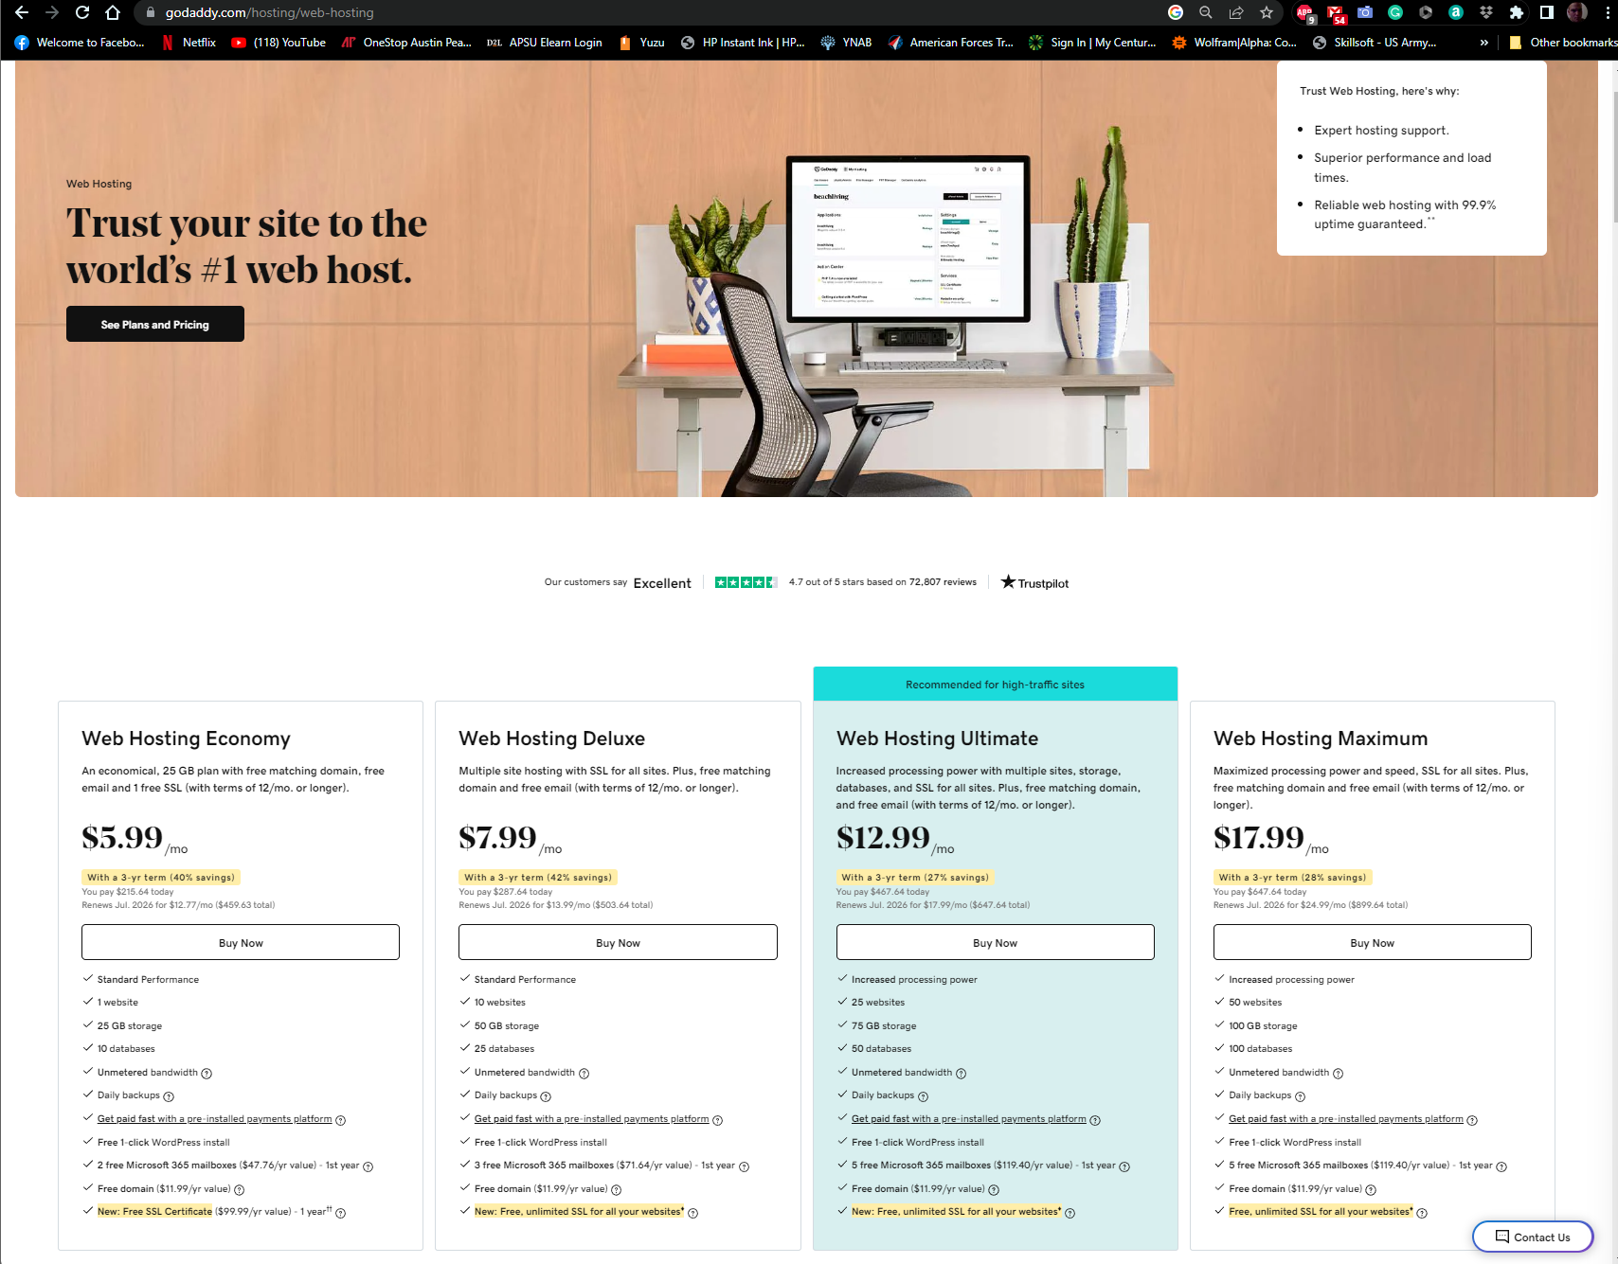

1. Blue host offers monthly solutions with dedicated IP in the Pro version. It offers storage solutions for each of its plans. The dedicated IP can be used to link to a firewall if needed.

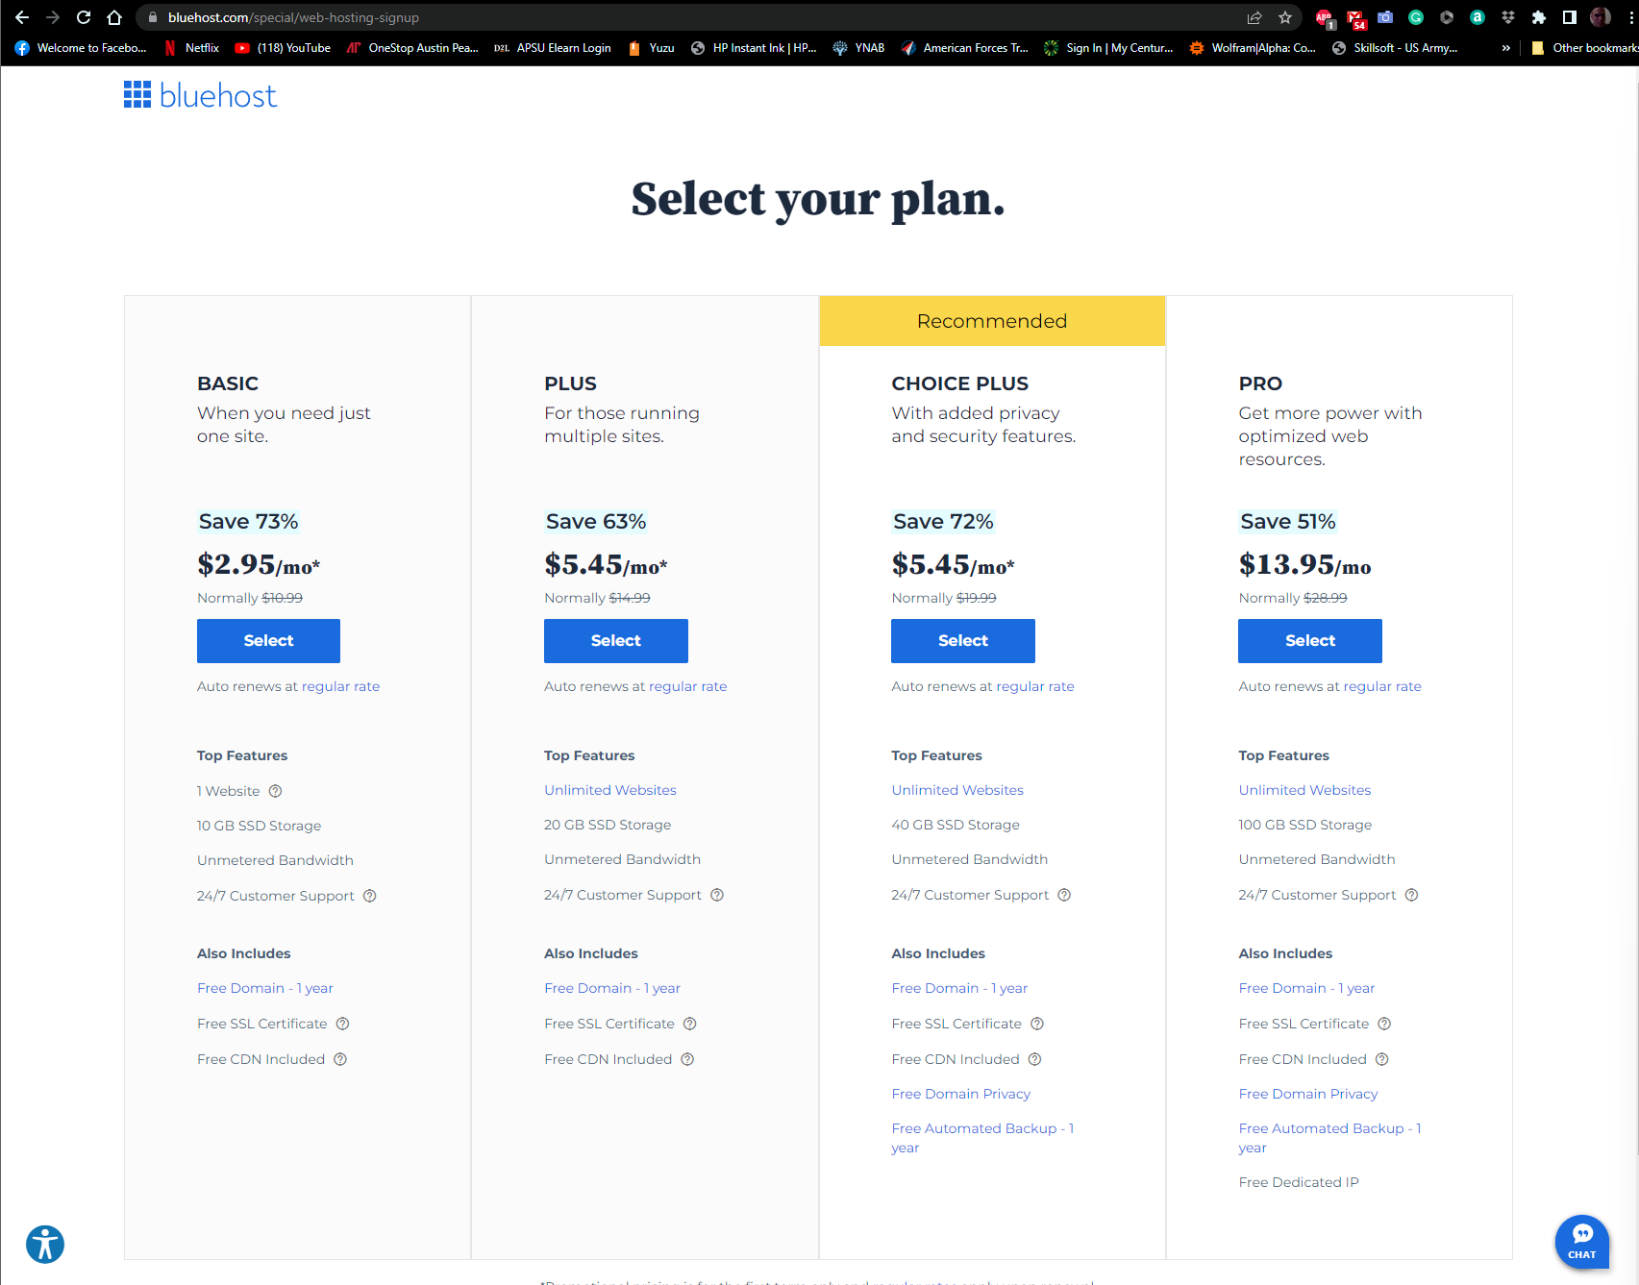

1. Gmail offers an HTML view version for low bandwidth users. It offers the option when loading passes a certain time. I used this option frequently when I worked in Afghanistan to access my personal email back in 2008. 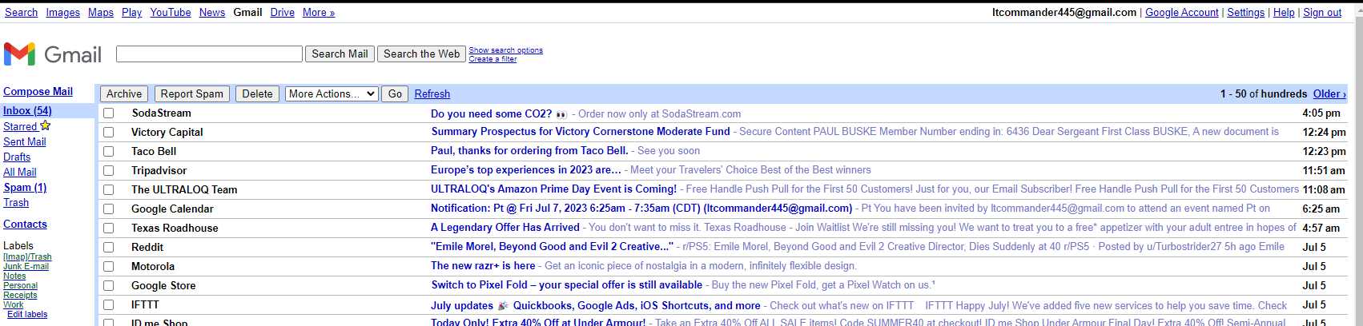

**Q2** (8 points):

[If two students submit similar answers or similar required examples, both students will receive 0 for this exam.]

What is Indexed Color (Web safe color)? We need to know it for historical reasons. (3 points)

* (Stated in D2L > PowerPoint Slide > Non Designer Web Book - other topics).

1. Web safe colors consists of colors originally considered “safe” in that they were cross supported by most popular browsers and operating systems. These colors were relevant back when computer displays were limited to 256 colors. Only 216 of the 256 colors were considered to have consistent enough support across platforms.

Please insert a real-world example, or image, or screen capture of indexed color, and **explain** what indexed color is. (5 points)

* Please quote source URL if applicable.

1. **Websafecolors.info/color-chart** lists the 216 colors considered to be web safe (indexed color). Notice how the hex code increases by 000033 scaling from black #000000 to white #ffffff. 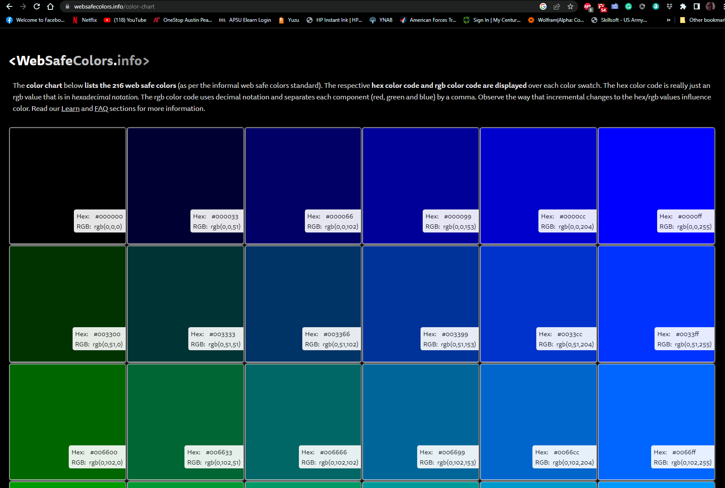

**Q3** (12 points):

[If two students submit similar answers or similar required examples, both students will receive 0 for this exam.]

Compare GIF file format and JPEG file format. Describe at least **four** differences between them. (4 points)

* (Stated in D2L > PowerPoint Slide > Non Designer Web Book - other topics).

1. GIF uses lossless compression while JPEG uses lossy compression. Lossy reduces file size by permanently removing some of the original data. Lossless reduces file size by removing unnecessary metadata.
2. GIF uses indexed colors while JPEG does not.
3. GIF supports animations while JPEG does not.
4. GIF supports one level of compression while the JPEG goes through many levels of compression. The GIF averages color when compressing to keep it 256 while the JPEG compression does a better job of keeping the original image’s color.

List four pairs (eight) of real-world examples to support and **explain** these four differences. (8 points, 2 points each)

* Insert real-world examples, or images, or screen captures to support your answer.
* Please quote source URL if applicable.

1. Lossless vs Lossy (https://www.adobe.com/uk/creativecloud/photography/discover/lossy-vs-lossless.html): The lossy image appears to be more grainy than the lossless image. You can see it along the outline of the frog against the black/grey background between the two images.

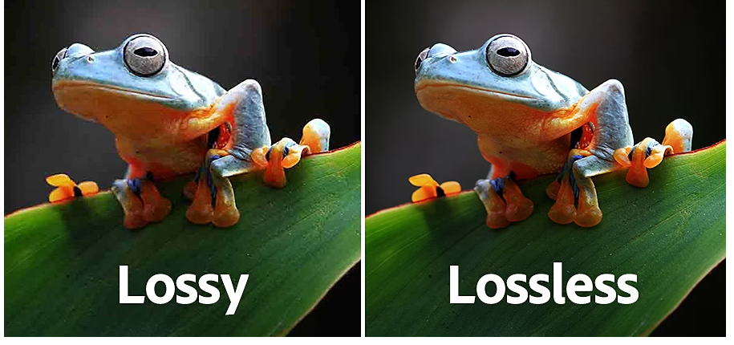

1. Indexed image (256) vs True color (<https://en.wikipedia.org/wiki/Indexed_color>): You can tell that the images use different color pallets. In the 256-color image, the parrot’s blue is almost the same shade of blue while the true color image offers a wider range of blue in the tips of the wings.

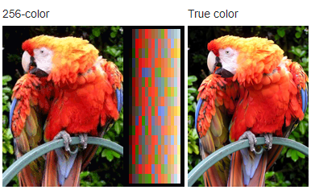

1. Animated nyan cat GIF (https://tenor.com/view/nyan-cat-rainbow-cat-kitten-kitty-gif-5716621) vs unanimated JPEG: The GIF is animated while the JPEG (https://en.wikipedia.org/wiki/Nyan_Cat) is not.

GIF JPEG

 

1. GIF compression vs JPEG compression and color (http://users.wfu.edu/matthews/misc/jpg_vs_gif/JpgVsGif.html): The JPEG on the left looks closer to the original image’s color while the GIF on the right tries to average the color using 256-color. That is why the GIF has the purple pixels.



**Q4** (12 points):

[If two students submit similar answers or similar required examples, both students will receive 0 for this exam.]

According to Jason Beaird’s book, color psychology is a field devoted to analyzing the emotional and behavioral effects produced by colors. Describe and **explain** the emotions the colors below are associated with. (4 points)

* (Stated in D2L > PowerPoint Slide Color - Jason).

1. Red is the color associated with passion, love, and excitement. Shades of red are often present in Valentine’s Day content.
2. Orange like red promotes happiness and excitement. It is used in images to create pop since it is a color that does not naturally occur often. It has been known to stimulate appetite which may be why it is a color most often associated with Halloween (candy sales).
3. Yellow like orange and red is associated with excitement and happiness. It is highly visible and often used to draw attention to itself which is why taxi cabs and caution signs often incorporate this color in their design.
4. Green is associated with nature, education, wealth, and stability. This is why most recycling bins are green or the symbol for recycling is often green.
5. Blue symbolizes openness, intelligence, and faith. It has calming effects and serves as an appetite suppressant. According to the book the appetite suppressant may be because most foods do not have a blue pigment in them. It is also associated with sadness which is why Blues music genre is titled as such.
6. Purple is associated with royalty and power. This may because producing the purple dye was difficult during the age of kings and queens. It balances the stimulating effects of red with the calming effects of blue.
7. White in Western cultures is associated with perfection, light, and purity. This is why white sheets are used in laundry commercials and why the bride’s wedding dress is white. In Chinese culture it is associated with death and mourning.
8. Black is associated with death, evil, power elegance, and strength depending on how it is used. This is why black is worn to show mourning in some cultures. It is also why formal events attended by the rich are often called “black tie” events.

List eight real-world examples to support and explain these eight colors / emotions. (8 points, 1 point each)

* Insert real-world examples (images, or screen captures) to support your answer.
* Please do NOT copy example from course slides / course textbooks / course assignments (0 points if copy from slides / textbook / assignments).
* Please quote source URL if applicable.

1. **Red** is often associated with passion and love. Valentine’s Day Card circa 1909. Cupids seen painting a heart with red (<https://en.wikipedia.org/wiki/Valentine%27s_Day#/media/File:Antique_Valentine_1909_01.jpg>):

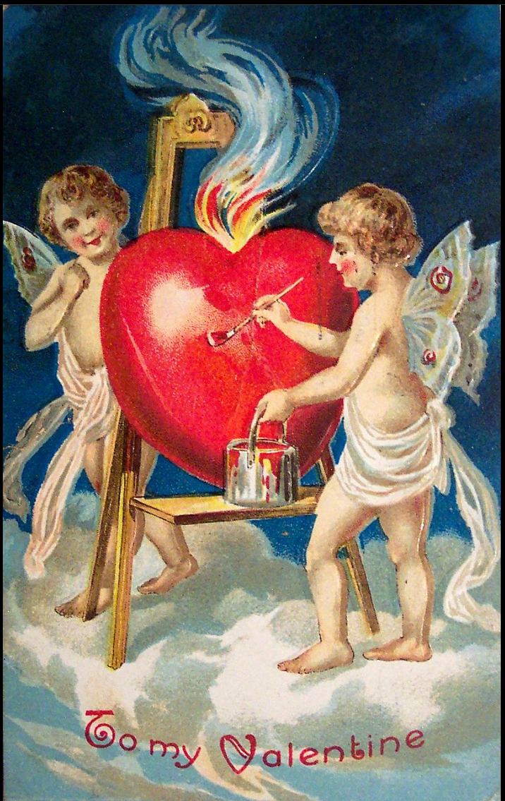

1. **Orange** is associated with Halloween and appetite. Candy corn is orange and seems to be available during Halloween (https://en.wikipedia.org/wiki/Candy_corn#/media/File:Candy-Corn.jpg):



1. **Yellow** its vibrancy is used to draw attention. It is often used in America for traffic signs (<https://www.firstsign.com/Right-Winding-Road-Traffic-sign-W1-5R-30>):



1. **Green** is associated with nature. Often used in American recycling programs (<https://unsplash.com/photos/FoG7PKNYjpM>):

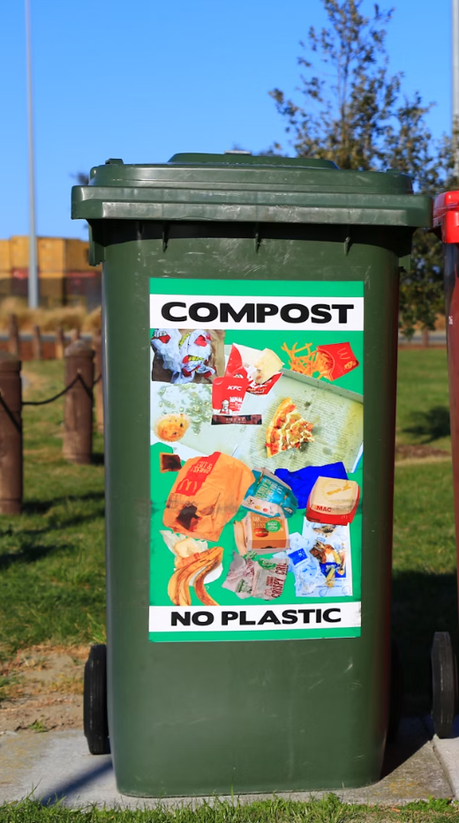

1. **Blue** is associated with sadness. Blues music is named after this connection (<https://unsplash.com/photos/2FMZ6LFNGBA>):

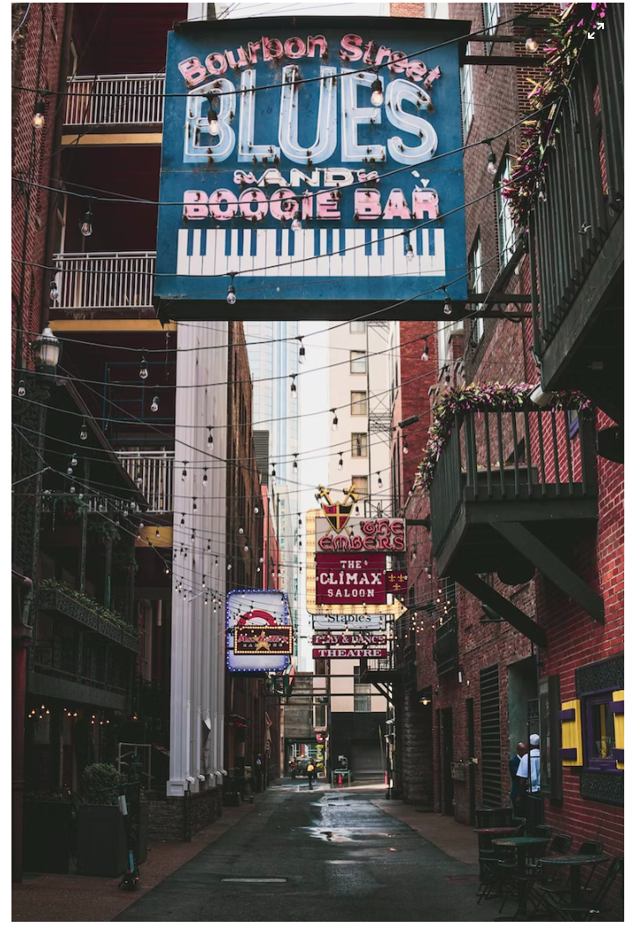

1. **Purple is** associated with power and royalty. Royal Purple is a motor oil brand that is purple <https://www.walmart.com/ip/Royal-Purple-High-Performance-Motor-Oil-5W-30-Premium-Synthetic-Motor-Oil-5-Quarts/35513146?athbdg=L1200>):

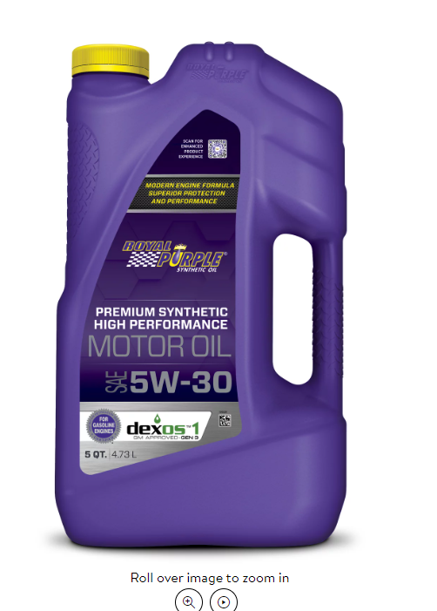

1. **White** is associated with purity in western cultures. Wedding dresses are white to symbolize the purity of the bride (<https://unsplash.com/photos/30UOqDM5QW0>):

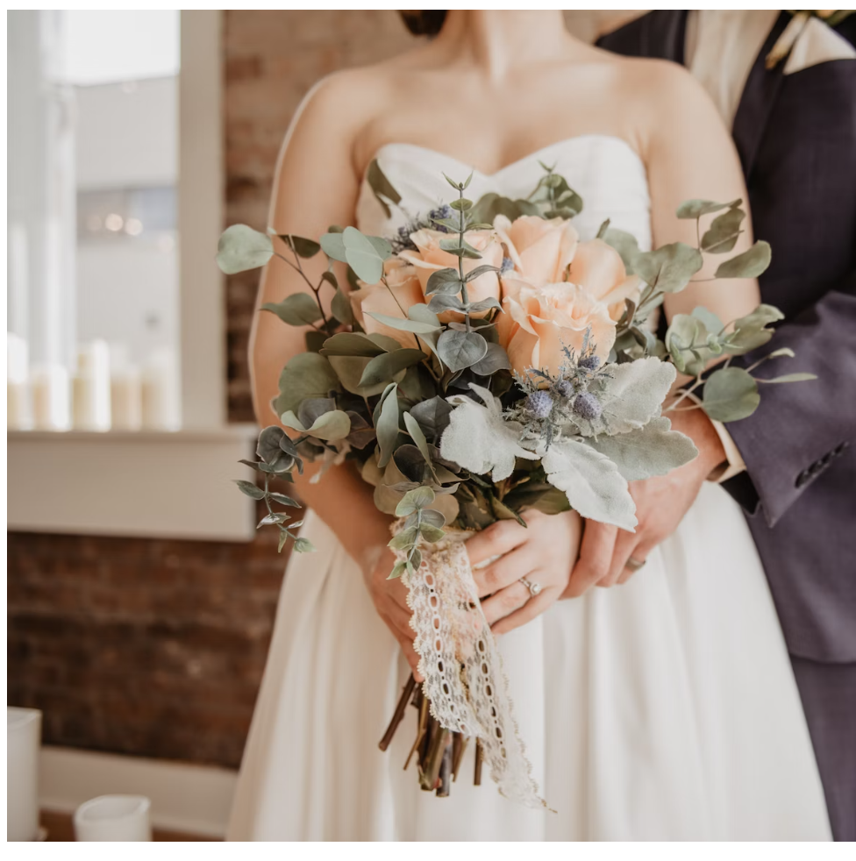

1. **Black** is associated with mourning in most wester cultures. Mourners are dressed in black in the photo below (<https://unsplash.com/photos/Cxpqnzd3Psg>):

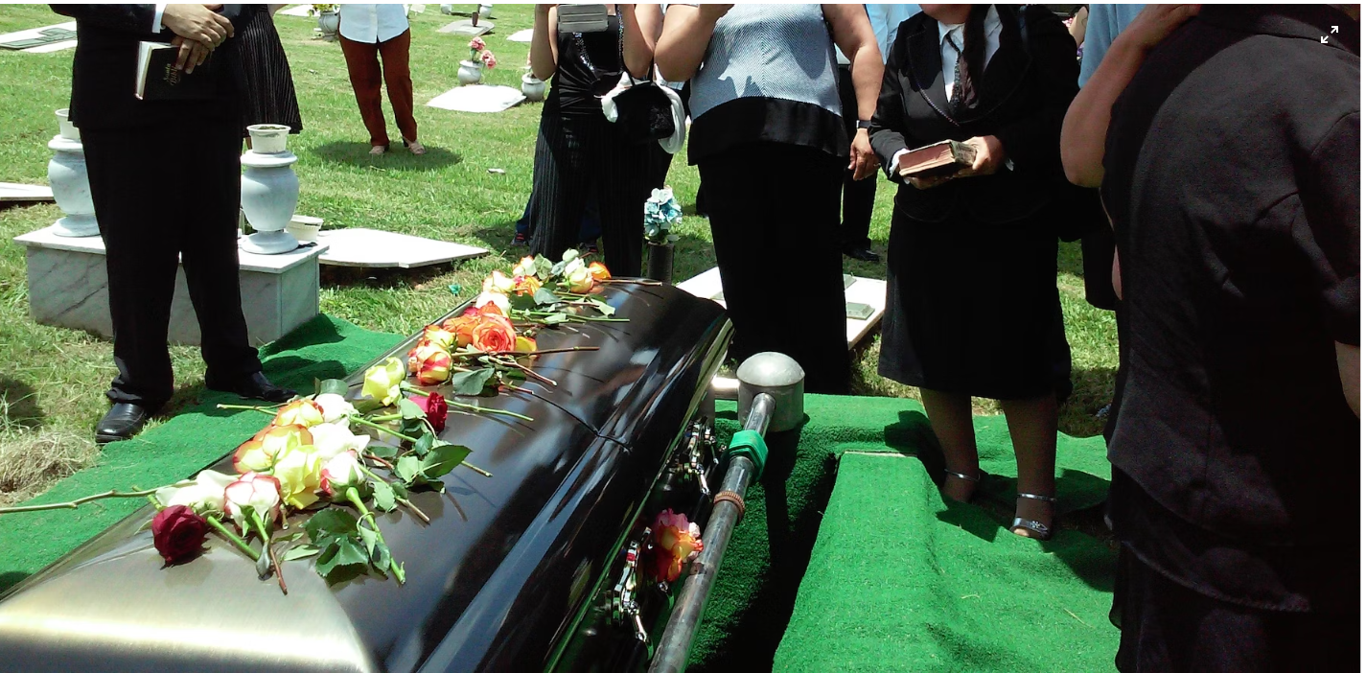

**Q5** (9 points):

[If two students submit similar answers or similar required examples, both students will receive 0 for this exam.]

List and describe (draw on a circle / simple color wheel) **three color schemes** (Jason stated 6 schemes). (3 points)

* Color scheme: how do we find multiple colors that work together using a color wheel?
* (Stated in D2L > PowerPoint Slide > Color - Jason).

1. Monochromatic color scheme consists of a single base color and tints and shades of that same color.
2. Analogous color scheme consists of three colors that adjacent to one another on the color wheel. As a rule, do not stray further than one-third away from a section of the color wheel according to Jason Beaird.
3. Complementary color scheme consists of up to three colors that are opposites of each other on the color wheel such as red, green, and blue.

List three real-world examples to support and **explain** these three color schemes. (6 points, 2 points each)

* Insert real-world examples, or images, or screen captures to support your answer.
* Please do NOT copy example from course slides / course textbooks / course assignments (0 points if copy from slides / textbook / assignments).
* Please quote source URL if applicable.

1. Monochromatic color scheme. Night vision optics used by the military produce monochromatic images of green (<https://en.wikipedia.org/wiki/Monochrome#/media/File:Afghan_National_Army_commandos_with_the_1st_Tolai,_6th_Special_Operations_Kandak_clear_a_compound_during_an_operation_in_Nejrab_district,_Kapisa_province,_Afghanistan,_Dec._16,_2013_131216-A-CL980-198.jpg>):



1. Analogous color scheme. According to uxplanet.org a common color scheme is red, red-orange, and orange. (<https://uxplanet.org/how-to-use-analogous-color-scheme-in-design-bf32d18ab05c>):

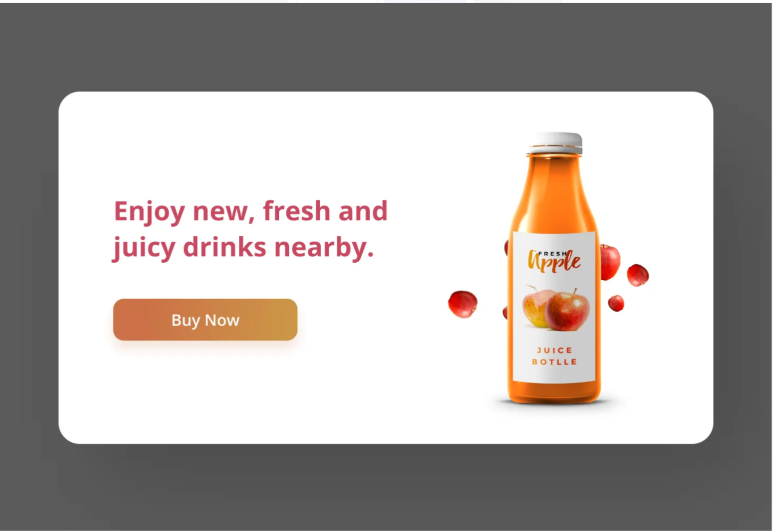

1. Complementary color scheme. Uxplanet.org uses the complementing colors of green and purple in their design of a film tile (<https://uxplanet.org/how-to-use-a-complementary-color-scheme-in-design-b50d06df24ef>):
2. 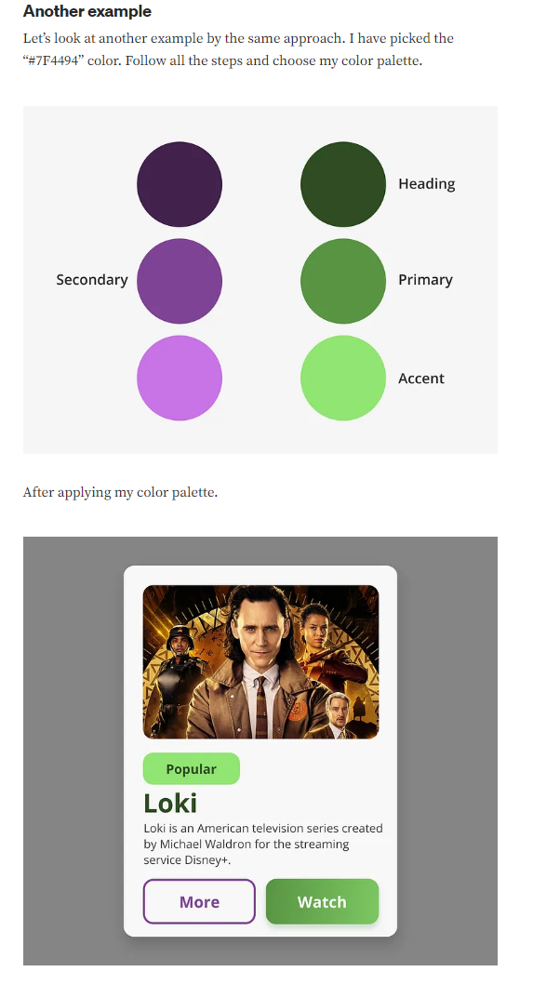

**Q6** (11 points):

[If two students submit similar answers or similar required examples, both students will receive 0 for this exam.]

Define and describe the Rule of Thirds. (4 points)

* (Stated in D2L > PowerPoint Slide > Layout and Composition - Jason).

1. The rule of thirds is a simplified version of the golden ratio. A line bisected by the golden ration is divided into two sections. One of the sections is twice the size of the other sections.

List a real-world example to support and **explain** the Rule of Thirds. (7 points)

* Insert real-world examples, or images, or screen captures to support your answer.
* Please do NOT copy example from course slides / course textbooks / course assignments (0 points if copy from slides / textbook / assignments).
* Please quote source URL if applicable.

1. Rule of thirds and the “Dragon” movie poster. The actor is bisected by the right quadrant with each of the attacking appendages in the center quadrant. The subtext is split into the left quadrant. The word legend his kicking, and “Lee Story” takes up the center quadrant. (https://reglosinger.wordpress.com/2016/09/10/structure-and-order-use-of-grid-system-and-rule-of-thirds-discussion-of-design-example/):

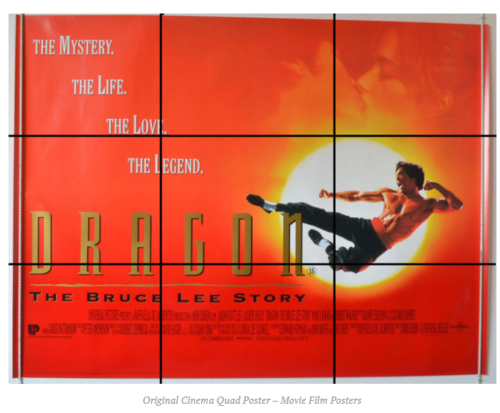

**Q7** (9 points):

[If two students submit similar answers or similar required examples, both students will receive 0 for this exam.]

What are the three bread-and-butter layouts (suggested by Jason Beaird – layout and composition)? (3 points)

* (Stated in D2L > PowerPoint Slide > Layout and Composition - Jason).

1. Left column navigation.
2. Three column navigation
3. Navigationless Magazine Style.

List three real-world examples to support and **explain** these three layouts. (6 points, 2 points each)

* Insert real-world examples, or images, or screen captures to support your answer.
* Please do NOT copy example from course slides / course textbooks / course assignments (0 points if copy from slides / textbook / assignments).
* Please quote source URL if applicable.

1. Left column navigation. Microsoft Outlook uses cascading menus of left column navigation. The out left has mail, calendar, contacts, to-dos, etc. The next menu is all of the user’s inboxes on the email panel. Then it has all the emails for that folder. Then finally the preview of the email. Source (my desktop):

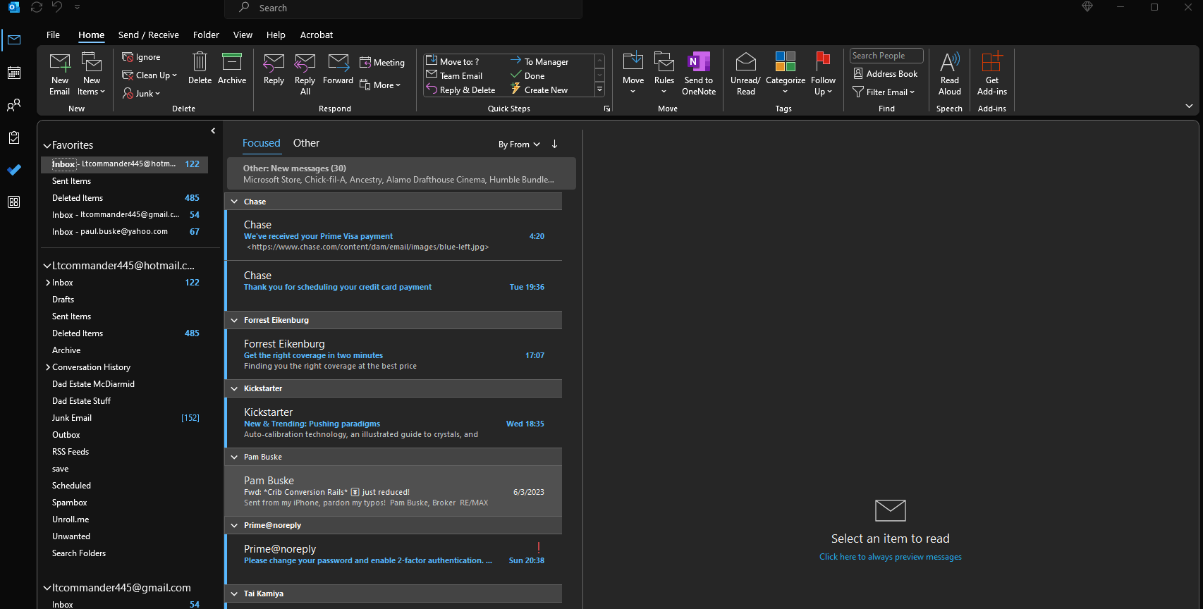

1. Three column navigation. Facebook makes heavy use of the three-column navigation. The left panel is all the different features of Facebook. The center is the services associated with the feature and the right is the Facebook messenger interface. (<https://www.facebook.com/>):

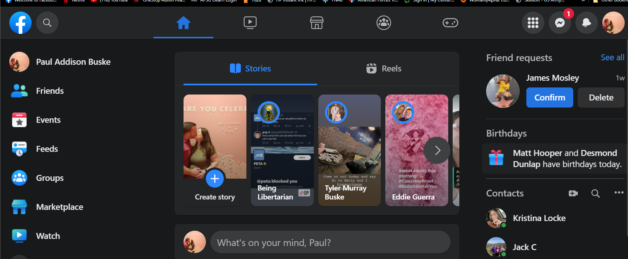

1. Navigationless Magazine Style. Vanity fair uses this design. Each page looks like a magazine with the content related to the corresponding topic meant to be consumed as a whole (<https://www.vanityfair.com/>):

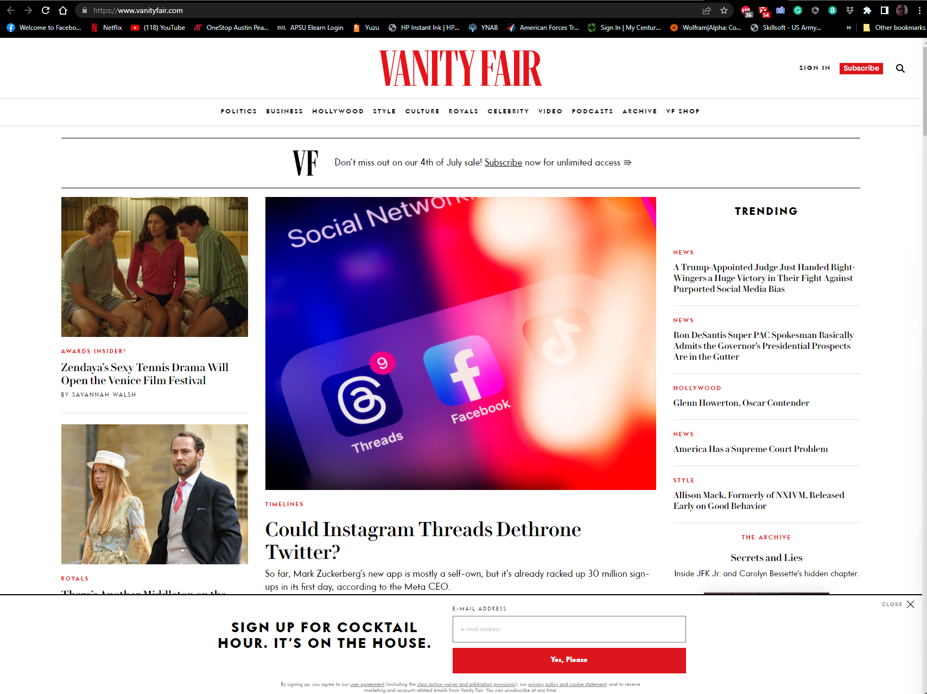

**Q8** (15 points):

[If two students submit similar answers or similar required examples, both students will receive 0 for this exam.]

List the five basic design / layout principles from **assignment 2**. (5 points)

1. Scale
2. Stability
3. Dynamics
4. Contrast
5. Asymmetric

List five real-world examples (e.g. images / photos) to support and **explain** these five layout principles. (10 points, 2 points each)

* Insert real-world examples, or images, or screen captures to support your answer.
* Please do NOT copy example from course slides / course textbooks / course assignments (0 points if copy from slides / textbook / assignments).
* Your drawing is NOT real-world example (0 points).
* Please quote source URL if applicable.

1. Scale refers to the relative size of an element compared to another element. The image shows the scale of the car by exaggerating the world around the car. The image is from the perspective of the toy which makes our world seem much bigger. (<https://unsplash.com/photos/-9U-msdVt1Y>):



1. Stability design principle refers to the static and predictable approach of the elements within a design. The Egyptian pyramids are a great example of stability. They give the sense that they will not move which is the definition of the design principle (<https://unsplash.com/photos/MoonoldXeqs>):

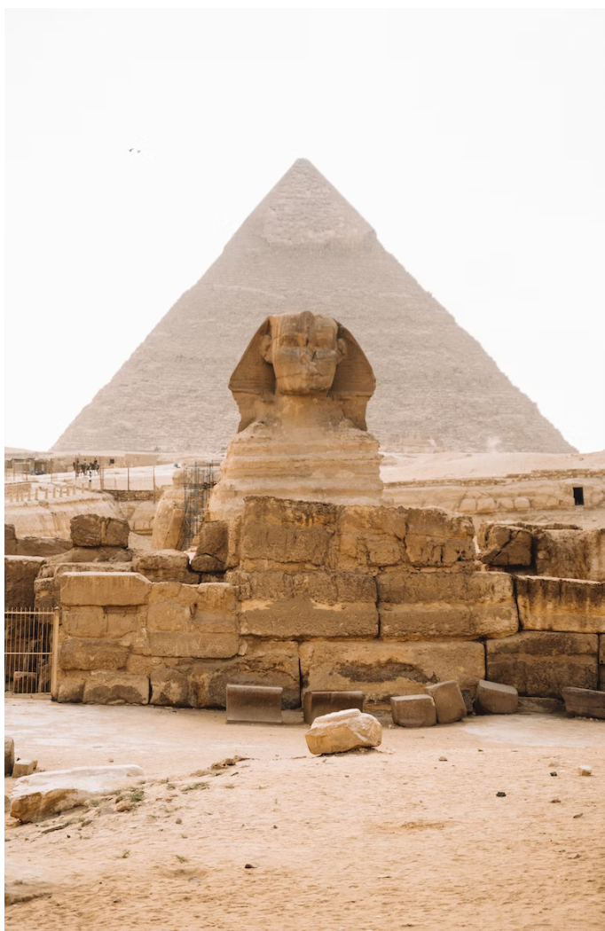

1. Dynamics design principle conveys a sense of movement or energy. The image illustrates dynamics which is a sense of the object being in motion. You can almost visualize the smoke rising and constantly taking new shapes as it dissipates. (<https://unsplash.com/photos/ouDz1gXoju4>):



1. Contrast design principle conveys a sense of opposites versions of something in age, size, shadow etc. This image does a great job of showcasing contrasts. It does so with both the color difference and the fact that one part of the field is barren while the other part is green and lush. It gives a sense of growth vs scarcity. (<https://unsplash.com/photos/XsAz9Mq61XY>):



1. Asymmetric is the same subject that can be bisected along a line where the subject contrasts itself. The house showcases asymmetric design in that the house is split down the middle. While it is the same house both sides of the split look like different houses.( <https://blog.qualitybath.com/home-and-design-inspiration/perfectly-irregular-asymmetrical-balance-in-home-design/>):

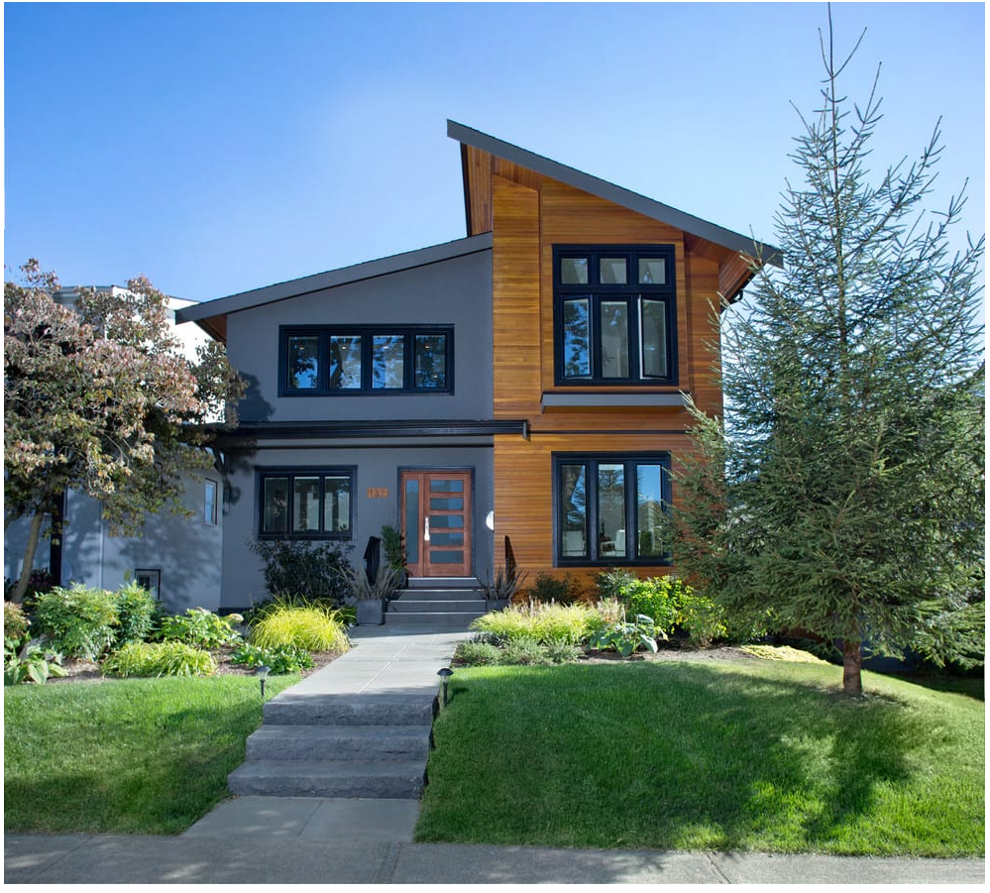

**Q9** (15 points):

[If two students submit similar answers or similar required examples, both students will receive 0 for this exam.]

List the four basic web design principles by Robin Williams, from **assignment 1**. (5 points)

1. Contrast
2. Repetition
3. Alignment
4. Proximity

List four real-world examples (e.g. images / photos) to support and **explain** these four design principles. (10 points, 2.5 points each)

* Insert real-world examples, or images, or screen captures to support your answer.
* Please do NOT copy example from course slides / course textbooks / course assignments (0 points if copy from slides / textbook / assignments).
* Your drawing is NOT real-world example (0 points).
* Please quote source URL if applicable.

1. Contrast is the principle where the sense of opposites is apparent to the viewer. The image below contrasts between the old unpainted/worn brick and the refreshed painted brick. The colors contrast between brick and white. (<https://unsplash.com/photos/O6uM94iMyVk>):

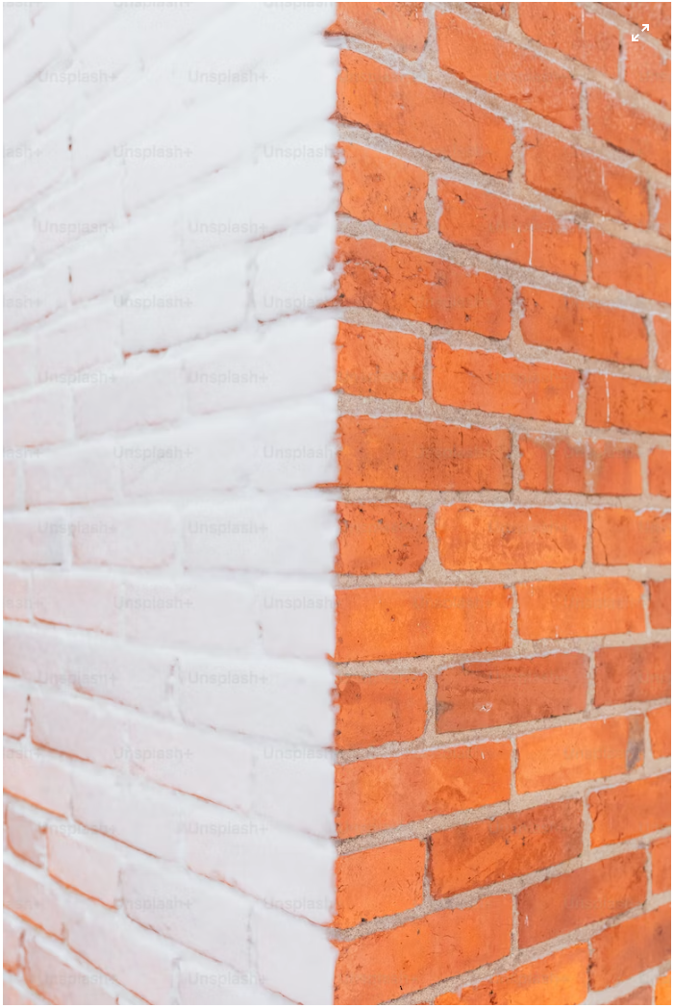

1. Repetition can be demonstrated with a predictable pattern that is apparent to the viewer. The clocks in the image showcase repetition in the time on the clocks, the model of the clocks, and the spacing between the clocks. (<https://unsplash.com/photos/ZNeuDlm0Ju8>):

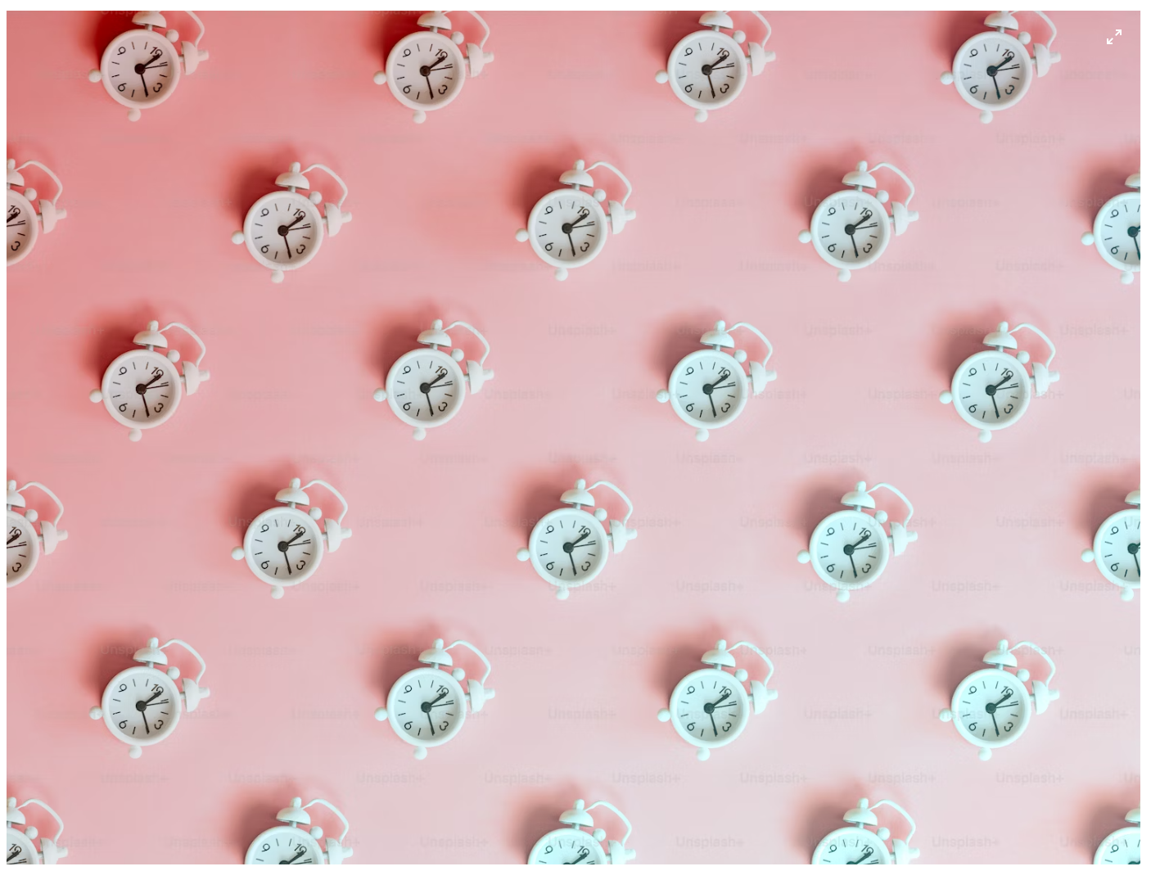

1. Alignment is showcased by aligning a subject to a certain position from the perspective of the viewer. Examples include left, right, bottom, and top alignment. The image showcases alignment by having the road aligned center. The road serves as the bisecting point and the rest of the image is almost symmetrical with the trees, fencing, and grass occupying roughly the same space on either side of the road. (<https://unsplash.com/photos/Xg1e5bR_bL4>):

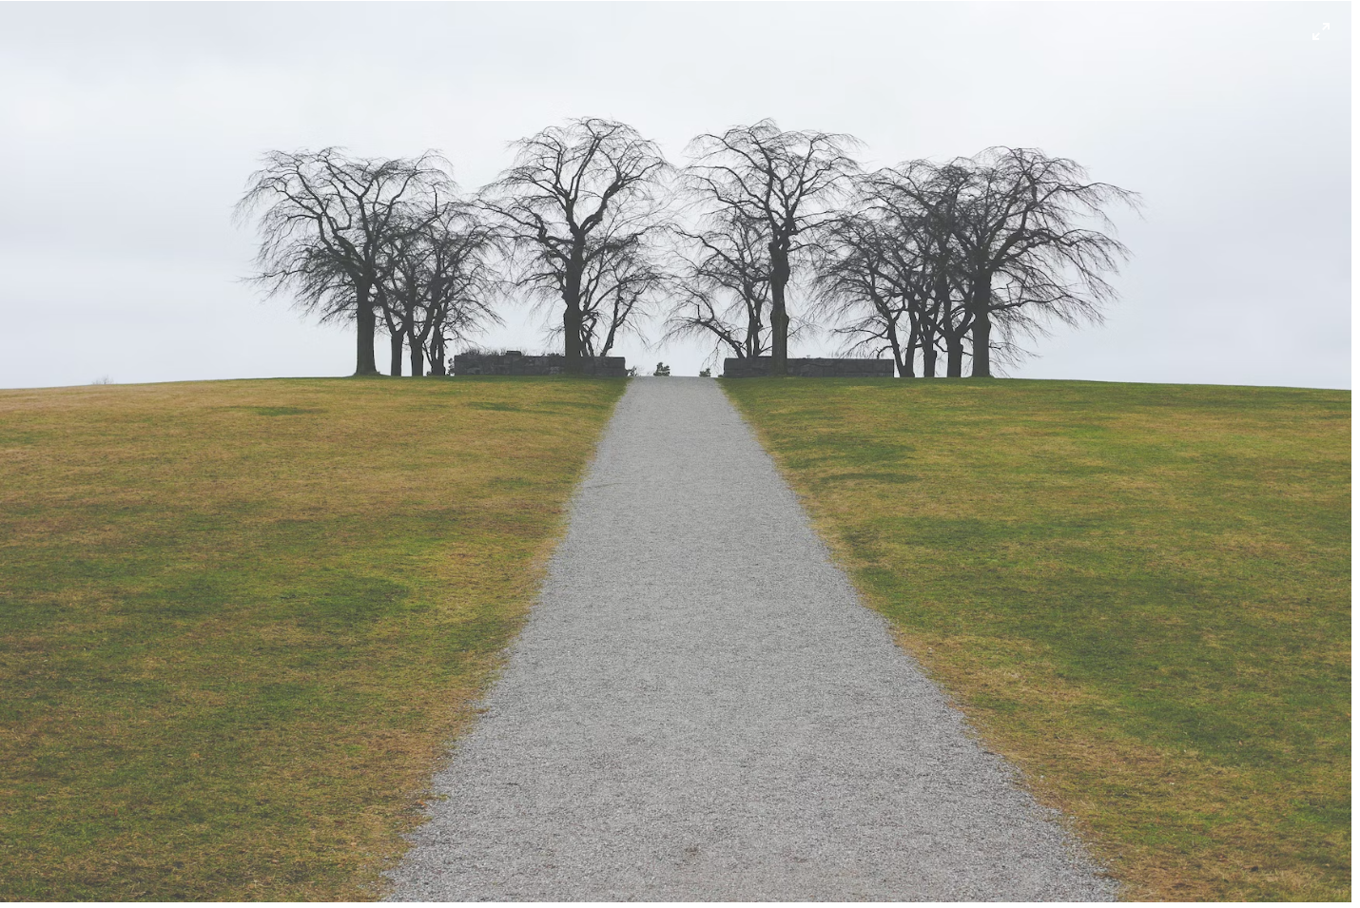

1. Proximity is the grouping of subjects that have similar use or behavior together. It gives a sense of balance of use to the user. The traffic sign below demonstrates proximity in that each side represents its own action of either stop or go. It is easy for the user to understand each light’s function within the sign. (<https://stefaniedec.files.wordpress.com/2011/09/smd_proximity1.jpg>):

